Kingston Elementary School--Lunch
News
STAFF BIRTHDAY’S
Mar 6th—Mrs.Skinner
Mar.15th—Mrs.H
Mar.17th—Mrs.Calahan
Mar.19th—Mrs.Mason

SCHOOL NEWS:
Mar 1st –school
Mar 22nd—student’s out @ 12:10
Mar.23rd—Mar.31st Spring Break.
Mar.20th–1st day of Spring

MILK CHOICES
1% FLAVORS
FF FLAVORS

MENU SUBJECT TO
CHANGE W/O
NOTICE

BREAKFAST SANDWICH
BABY CAKES
FRUIT CHOICES
KETCHUP
MUSTARD

MINI CORN DOGS
BAKED BEAN MIX
FRUIT CHOICES
COND.

COOK’S CHOICE
VEGETABLES
FRUIT CHOICES

HOT HAM & CHEESE ON A BUN
OVEN FRIES
FRUIT CHOICES
COND.

PHILLY STEAK ON SUB BUN
MIXED VEGETABLES
FRUIT CHOICES

PEPPERONI PIZZA
CARROTS
FRUIT CHOICES
LITE RANCH

CHEESE BREAD BITES
BABY CARROTS
MARINARA SAUCE CUPS
FRUIT CHOICES

TACO’S
REFRIED BEANS
SALSA CUP
LETTUCE
FRUIT CHOICES

PIZZA ROUNDS
CORN
FRUIT CHOICES
LITE RANCH

LUNCH MEAT SUBS
FRESH VEGGIES
FRUIT CHOICES
COND.
BAG OF POTATO CHIPS
NATIONAL POTATO CHIP DAY!

FISH STICKS
COLE SLAW
FRUIT CHOICES
COND.

SLOPPY JOE’S
GREEN BEANS
FRUIT CHOICES

NATIONAL SLOPPY JOE DAY!

CHICKEN NUGGETS
CARROTS
FRUIT CHOICES
SAUCES
BREAD PRODUCT

RAVIOLI
CORN
FRUIT CHOICES
GARLIC BREAD

NATIONAL RAVIOLI DAY!

COOK’S CHOICE
VEGETABLES
FRUIT CHOICES

NACHO’S
REFRIED BEANS
LETTUCE
FRUIT CHOICES
LITE RANCH

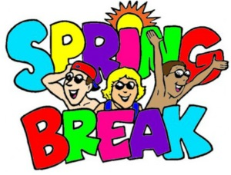

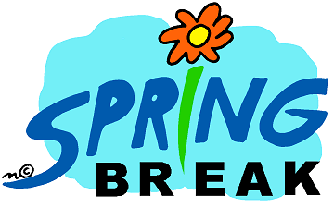
Enter Text Here

