Kingston Elementary--Breakfast
News
MARCH 1ST-SNOW DAY MAKE UP.

SPRING BREAK STARTS
AT 12:11 ON MARCH 22ND

SEE YOU BACK ON APRIL 1ST NO FOOLIN’

MENU SUBJECT TO
CHANGE W/O
NOTICE

MILK CHOICES
1% & FF

BOILED EGG
PB TOAST CRACKERS
APPLESAUCE CUP
100% GRAPE JUICE

POP TART
CHEESE STICK
PEACH CUP
100% BERRY JUICE

BENEFIT BAR
APPLE SLICES
100% STRAWBERRY KIWI
JUICE

DUNKIN STICK
VANILLA GOLD FISH
RAISINS
100% APPLE JUICE

NATIONAL CEREAL DAY!

CEREAL BAR KIT
PEAR CUP

HOT BREAKFAST DAY

HOT ITEMS
COLD CEREAL
FRUIT
100% ORANGE JUICE CUP

CRUNCH MANIA
CRAISINS
100% FRUIT PUNCH JUICE

BREAKFAST BREAD SLICE
APPLE SLICES
100% WHITE GRAPE JUICE

P.B. SANDWICH
APPLESAUCE CUP
100% BERRY JUICE

MUFFIN
CHEESE STICK
PEAR CUP
100% GRAPE JUICE

BAGELS
SPREADS
RAISINS
100% APPLE JUICE

YOGURT
GRANOLA POUCH
PEACH CUP
100% WHITE GRAPE JUICE

UBR ROUND
APPLE SLICES
100% ORANGE TANGERINE
JUICE

OUR CHOICES
ON EVERYTHING
SPRING CLEAN OUT.

BB ELFIN LOAF
GRAHAMS
MANDARIN ORANGE CUP
100% APPLE JUICE

KIDS OUT @ 12:10

ULTRA CINN ROLL
APPLESAUCE CUP
100% STRAWBERRY KIWI JUICE
CHOCOLATE MILK
WHITE MILK
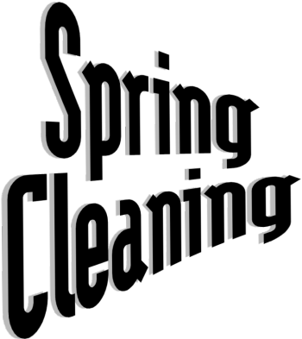

Enter Text Here

