KINGSTON ELEMENTARY--LUNCH
News
Sept. 12th—Students out @ 12:10
Sept. 27th---Fall fundraiser kick off

STAFF BIRTHDAY’S
Sept 12th—Mr Peet
Sept.30th—Mrs.Powell

LABOR DAY

NO SCHOOL

CHEESE FILLED BREAD BITES
COOKED CARROTS
FRUIT CHOICES
MARINARA SAUCE CUPS

CHICKEN DAY
CORN
FRUIT CHOICES
6TH GRADE BREAD PRODUCT

Enter Text Here

TURKEY N VEGETABLES AND GRAVY OVER
BISCUITS
OR CHILI CHEESE WRAP
FRUIT CHOICES

HAMBURGERS
FRIES
FRUIT CHOICES
KETCHUP
MUSTARD

CHICKEN NUGGETS
SUPER SLAW
FRUIT CHOICES
KETCHUP
HONEY MUSTARD

TACO TUESDAY
ON SOFT SHELL
LETTUCE
FIESTA BEANS
FRUIT CHOICES
SOUR CREAM
SALSA CUP

BEEF RAVIOLI
OR MAC N CHEESE
COOKED BROCCOLI
FRUIT CHOICES
GARLIC FLAT BREAD

BREAKFAST SANDWICH
EGG, SAUSAGE, CHEESE
HASHBROWN
FRUIT CHOICES

CHICKEN WRAPS
CARROTS & CELERY
LETTUCE
FRUIT CHOICES
COND.

MINI CORN DOGS
BAKED BEANS
FRUIT CHOICES
KETCHUP
MUSTARD

CHEESE PIZZA
BABY CARROTS
FRUIT CHOICES
LITE RANCH

NACHO’S
TORTILLA CHIPS
REFRIED BEANS
LETTUCE
FRUIT CHOICES

SPAGHETTI W/ MEATBALLS
SUPER SLAW
FRUIT CHOICES
GARLIC BREAD
PARMESAN CHEESE

CHICKEN PATTY ON A W.G. BUN
GREEN BEANS
FRUIT CHOICES
COND.

SLOPPY JOE
SMILE POTATOES
FRUIT CHOICES

CHICKEN AND CHEESE QUESADILLA
CARROTS
FRUIT CHOICES
LITE RANCH

BREADED CHICKEN LEG
MASH POTATOES
GRAVY
CORN
FRUIT CHOICES
PRES. COOKIES

HOT DOG
BAKED BEAN MIX
FRUIT CHOICES
KETCHUP
MUSTARD

COBB SALAD
FRUIT CHOICES
CRACKERS
DRESSING CHOICE

PEPPERONI PIZZA
BABY CARROTS
FRESH BROCCOLI
FRUIT CHOICES
LITE RANCH

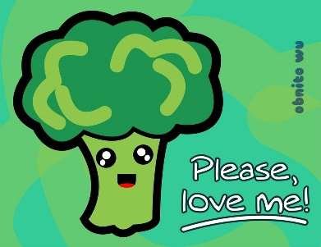

MILK CHOICES
1% CHOCOLATE
1% WHITE
STRAWBERRY
FF WHITE

Enter Text Here

