KINGSTON ELEMENTARY--BREAKFAST
News

SEPT 2ND—LABOR DAY
SEPT 12TH—STUDENTS OUT AT 12:10
Sept 13th—Hot Breakfast
Sept.27th—Hot Breakfast

LABOR DAY

NO SCHOOL

CRUNCHMANIA GRAHAMS
PEACH CUP
100% GRAPE JUICE

FROSTED MINI WHEATS
GRAHAM CRACKERS
MANDARIN ORANGE CUP
100% APPLE JUICE

Enter Text Here

DUNKIN STICK
YOGURT
DICED PEAR CUP
100% STRAWBERRY KIWI JUICE

MISC. BAG DAY
FRUIT CUP
100% CRAN RASPBERRY JUICE

SCOOBY DOO GRAHAMS
2ND GRAIN CHOICE
APPLESAUCE CUP
100% FRUIT PUNCH JUICE

CHOCOLATE MUFFIN
CHEESE STICK
APPLE SLICES
100% WHITE GRAPE JUICE

P.B. WAFER SANDWICH
FRESH GRAPES
100% BERRY JUICE

BB ELFIN LOAF
GRAHAMS
FRESH APPLE SLICES
100% ORANGE TANGERINE JUICE

HOT BREAKFAST
DIFFERENT HOT ITEMS
COLD CEREAL
FRUIT CHOICES
100% ORANGE JUICE CUP

W.G. POP TART
GRAHAMS
APPLESAUCE CUP
100% GRAPE JUICE

2 SUPER STAR DONUT BALLS
FRESH GRAPES
100% STRAWBERRY KIWI JUICE

CEREAL BAR
GOLD FISH CRACKERS
FRESH APPLE SLICES
100% ORANGE TANGERINE

UBR ROUNDS
FRESH GRAPES
100% BERRY JUICE

BANANA CHOCOLATE CHUNK
BENEFIT BAR
FRESH GRAPES
100% APPLE JUICE

CHEERIOS
BUG BITES
MANDARIN ORANGES CUP
100% APPLE JUICE

SCOOBY DOO GRAHAMS
YOGURT
FRESH APPLE SLICES
100% GRAPE JUICE

W.G. MUFFIN
CHEESE STICK
FRESH GRAPES
100% STRAWBERRY KIWI JUICE

BREAKFAST BREAD SLICES
FRESH APPLE SLICES
100% WHITE GRAPE JUICE

HOT BREAKFAST
BREAKFAST PIZZA
SAUSAGE BISCUIT SANDWICH
FRESH FRUIT
100% FRUIT JUICE CUP

CHEEZ IT CRACKERS
GRAHAMS
PEACH CUP
100% BERRY JUICE

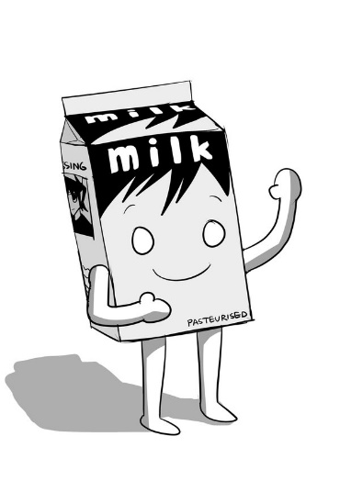

MILK CHOICES
1% WHITE
FF WHITE

Enter Text Here

